# Meeting 4

Rui Castro & Martin, 29-09-2021, duration: 60 minutes.

Discussed progress, thought about extending the 2D scenario to the more dimensional scenario.

TODO: Check whether this is the right formulation for n = 2, and think about higher dimensions, how do we write this for n = 3, etc.?

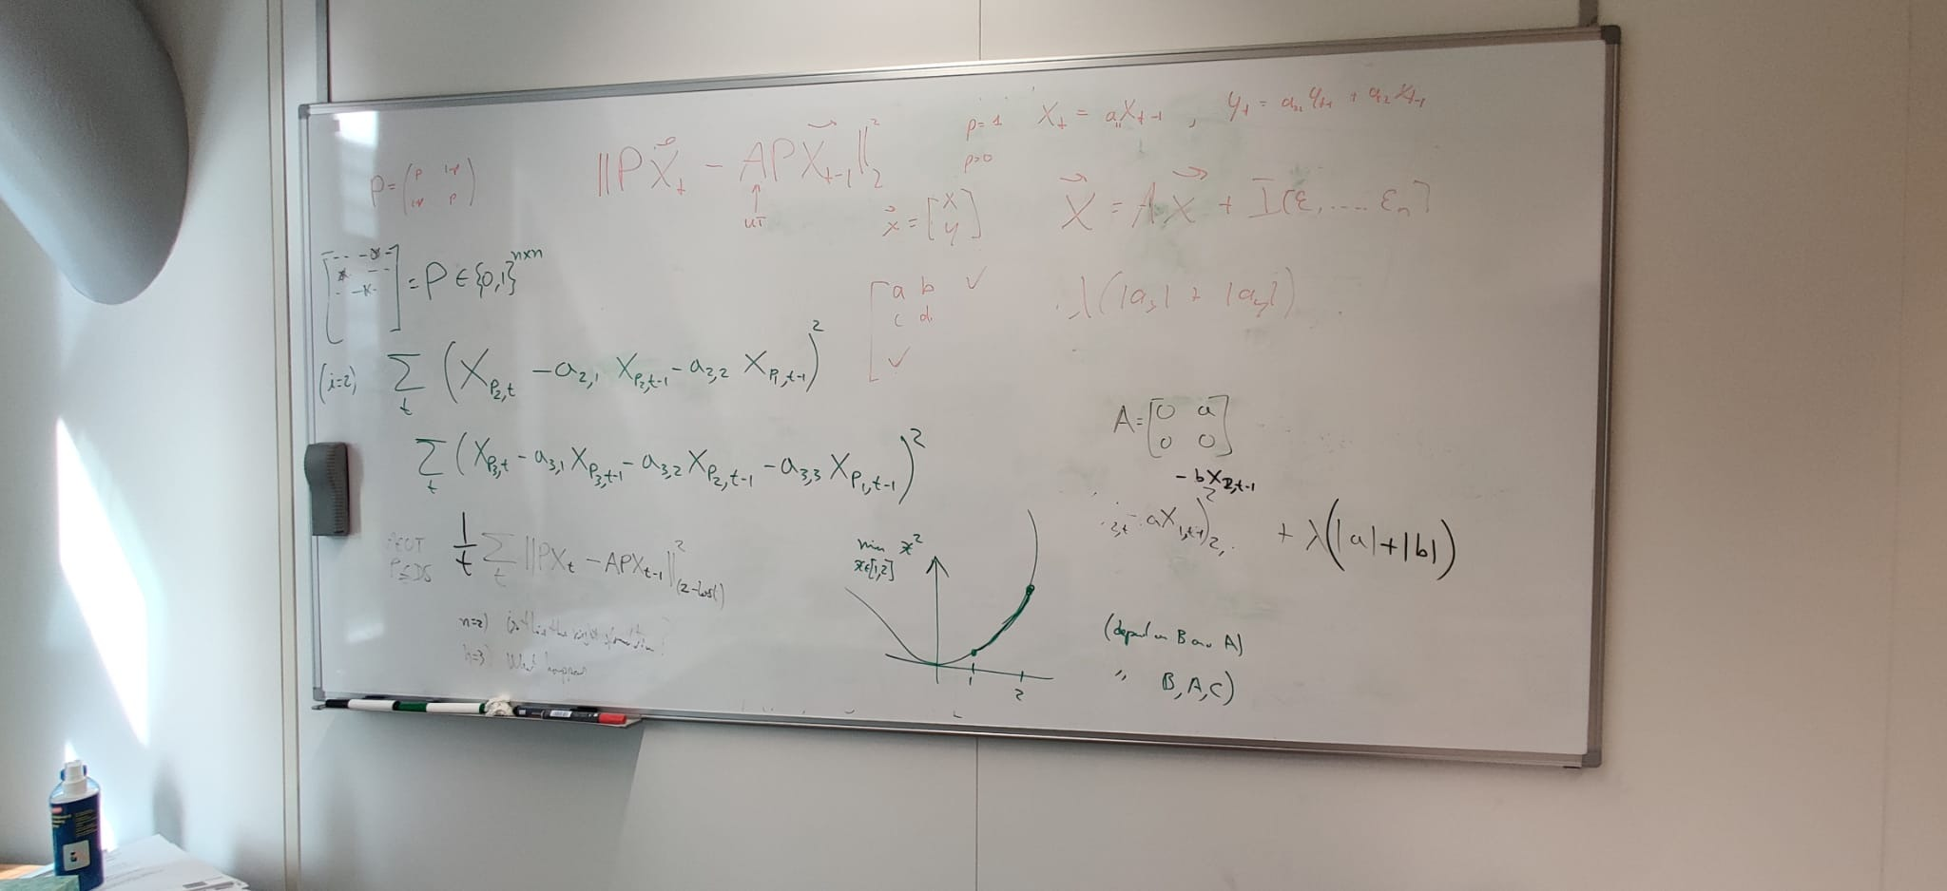

Richard will be joining next week, as well as a postdoc who is working with ASML on causal inference as well. Informal meeting, so no need to prepare extra, just normal what you always do 😊.